# CS 255 System Design Document Template

This template lays out all the sections you need to complete for Project Two. Each section has guidance to prompt your thinking. You will need to continually reference the interview transcript as you work to make sure that you are addressing your client’s needs. There is no required length for the final document. Instead, the goal is to complete each section based on what your client’s needs are. Remove this note when you are finished, and replace all bracketed text with the relevant information.

## UML Diagrams

### UML Use Case Diagram

### UML Activity Diagrams

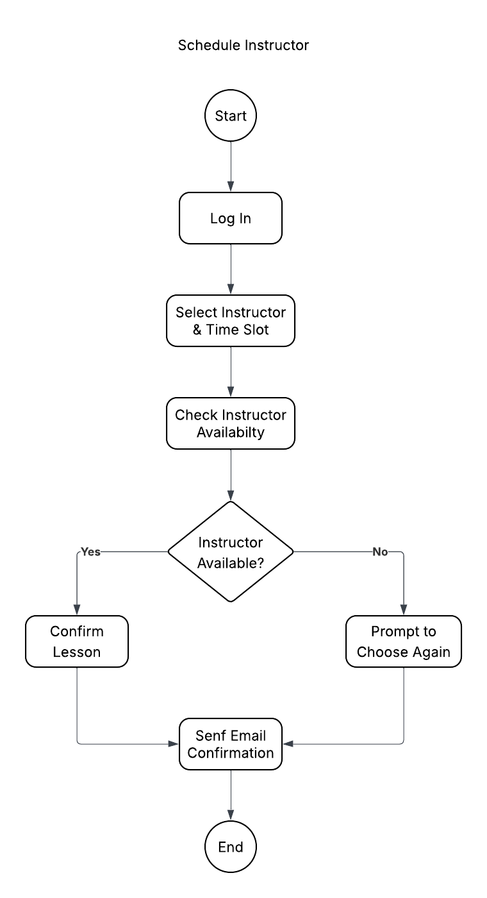

### UML Sequence Diagram

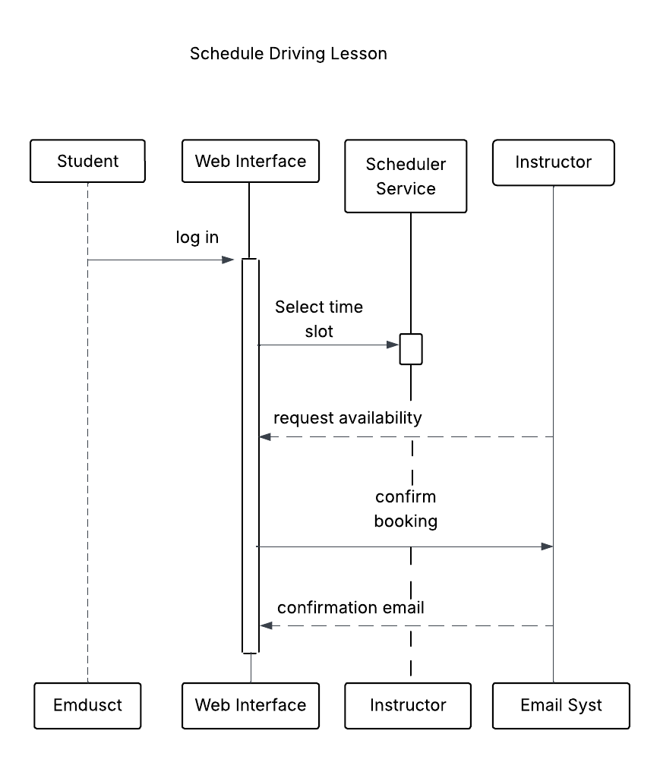

### UML Class Diagram

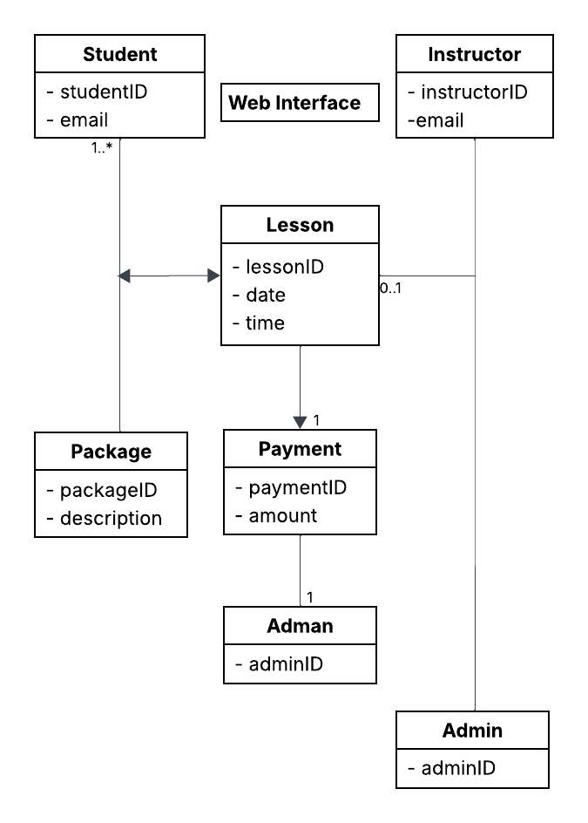

## Technical Requirements

Technical Requirements

What You’ll Need in Addition To operate the DriverPass system smoothly and securely, the following items are required:

Devices and Equipment

For Students, Faculty, and Admins:

Any new or old device – be it a PC, laptop, tablet, or smartphone with stable internet connectivity will suffice. For good experience, devices must have sufficient memory (at least 4 GB of RAM) and a reliable internet connection (at least 5 Mbps download speed).

For Hosting the System:

A dependable server (could be cloud- or machine-based) is needed to keep the data and the application running. It will need powerful processing and fast storage, and the capability to stay online all the time.

Software and Tools

For the User Interface:

The system will rely on modern website technologies so users can connect through standard internet browsers such as Chrome, Firefox, or Edge. The layout will be adapted to different screen sizes.

For Behind-the-Scenes Work:

The backend system will operate on safe and efficient software and have a good programming setup in place that will be able to process logins, lesson bookings, and other requests. A good database will track customer profiles, lesson timings, invoices, and so on.

Communication and Payment:

Confirmation and reminder emails will be sent using email services. Purchases will be conducted securely by a reputable payment processor (Stripe, PayPal, etc.).

For system development and maintenance:

Common tools for coding, error checking, feature testing, and progress tracking will be employed by developers. We will use diagrams and planning tools to design and update the system architecture.

Online Hosting and Security

Where the System Lives:

Hosting: It will be a reliable cloud provider for us (AWS, Azure, or Google Cloud). This keeps the system up 24/7 and can be scaled up when we have more users.

Keeping Information Safe:

All information that is sent back and forth between the system and users will be encrypted in a secure manner. The user will only be able to access the specific features if they are approved. Passwords will be stored securely, and rogue activity will be blocked via native protection inside the device.

Monitoring and Improvements:

The system will feature tools to monitor performance and catch problems early. It can also be easily updated/expanded to cater to future requirements.